**Small Rain Gauge Method of Monitoring Leachate Volume in Container Nurseries**

**Jeff Million1 and Tom Yeager1\***

1Department of Environmental Horticulture, University of Florida, IFAS

Gainesville, FL 32611

**Additional index words**. best management practice, irrigation, leachate fraction, tipping bucket

**An important irrigation best management practice (BMP) for container nurseries is routinely assessing container drainage and adjusting irrigation to target a low leaching fraction. A leaching fraction (LF) is the amount of drainage from a container after irrigation divided by the total water applied. The traditional method of collecting leachate and manually measuring the volume is labor intensive and is a deterrent for adopting this BMP. We describe and evaluate the use of a small tipping bucket rain gauge in a flow-through leachate monitoring system which reduces time and labor. Calibration tests indicated a tip volume of 1.7 mL per tip was maintained if the flow rate of leachate into the gauge was <60 mL·min-1. Because leachate flow rates for spray-stake irrigation may exceed this rate, a sand filter collector should be implemented to slow leachate flow rates to an acceptable level. If maintained and routinely used, the tipping bucket rain gauge system can provide a convenient means for monitoring leachate and adjusting irrigation in container nurseries.**

_________

Trade names, products, and companies are mentioned for informational purposes only. Component parts are listed using common terminology. The authors gratefully acknowledge the support of FNGLA Endowed Research Fund, Virginia Nursery and Landscape Horticultural Research Foundation, and Saunders Brothers Nursery. Yvette Goodiel, John Roberts, and Christine Russo provided comments about the draft manuscript.

*Corresponding author. Email: yeagert@ufl.edu

Efficient irrigation scheduling during production of container-grown plants is challenging as the confined container substrate volume requires frequent applications of water to maintain adequate substrate moisture. The goal of efficient irrigation is to apply sufficient water for plant growth with minimal container drainage. In addition to saving water, minimizing container drainage can help minimize the leaching losses of applied agrichemicals such as fertilizer nutrients.

An important irrigation best management practice (BMP) is assessing container drainage every one to three weeks and adjusting irrigation to target a low leaching fraction (Florida Dept. Agric. Consumer Serv., 2014). A leaching fraction (LF) is the amount of drainage from a container after irrigation divided by the total water applied. The amounts of drainage and irrigation water are commonly determined by setting up collection systems and manually weighing collected volumes of water. This manual method of determining LF has some advantages and disadvantages. A major advantage is the visual impact the collected volume of water has on the LF tester. Little or no drainage as well as excessive drainage volumes are easy to visualize without weighing, and thereby conveys to the tester the need for an irrigation adjustment. However, the labor required to test multiple areas on a routine basis is preventing many nurseries from adopting the practice, even when they see the potential benefits. It is recommended to test on days with normal or above normal evapotranspiration rates which can be challenging in a nursery with fixed labor schedules. Additionally, performing an LF test during periods of frequent precipitation can invalidate results, further increasing labor efforts. To overcome these labor constraints, technologies which reduce the labor inputs of LF testing should be explored.

The use of a tipping bucket rain gauge is one potential method for continuously monitoring the LF. The principle of the tipping bucket rain gauge has been successful since its invention in 1662 by Wren and Hooke (Biswas, 1967). A typical rain gauge has two buckets that pivot in a ‘seesaw’ action on an axle. The rain gauge’s collector directs water onto one of the two buckets and the bucket tips when a given volume is reached. Once one bucket tips, the other bucket begins to fill and eventually tip, and so forth. A magnet attached to the bucket mechanism activates a reed switch at every tip allowing for the number of tips to be recorded. The volume of each tip is then used to determine the amount of water received. For meteorological applications, standard rain gauge collectors have a diameter of 20.3 cm with a bucket tip volume of 8.2 mL.

Tipping bucket rain gauges have been used in the measurement of drainage from field (Edwards et al., 1974; Khan and Ong, 1997; Zhao et al., 2001) and container-grown (Cypher, 2021; Zhu et al., 2005) crops. For field applications, large tipping buckets (e.g. >10 L) have been used to handle potentially high drainage volumes. Edwards et al. (1974) described sources of variation when conducting calibration tests on these large buckets including variable inflow rate, flow turbulence, and surface tension effects. For studying irrigation scheduling effects on leachate volume and nutrient content, Zhu et al. (2005) used a standard 20.3-cm diameter rain gauge to measure container drainage collected from five 57 L (trade #15 gallon) pot-in-pot containers via a below-ground collection system that directed drainage through the gauge and into a sump located at the edge of the production area. A data logger recorded the number of tips, and leachate volume was calculated based on a calibration curve established for the field’s irrigation application rate. An error of 5% was attained using the field calibration for the system; therefore, this method showed great promise for continuously monitoring leachate in research trials. They also conducted a standard calibration by applying 2000 mL of water at various rates by drilling holes in the cap of an inverted 2-L plastic bottle. For this calibration, the volume per tip increased non-linearly from 7.5 mL per tip at an average flow rate of 24 mL·min-1 to 12.5 mL per tip at an average flow rate of 993 mL·min-1. The spray-stake-irrigation application rates were 193 and 451 mL·min-1, and the observed peak leachate drainage rates were >200 mL·min-1and >600 mL·min-1, respectively. These results clearly show that calibration of a tipping bucket needs to be assessed when using it in applications other than rainfall.

If a standard tipping bucket rain gauge sensor with a height of 20-25 cm is to be used for monitoring container leachate and not buried below ground, the container would have to be raised to an undesirable height. A smaller tipping bucket sensor with a low profile used above ground would improve the ability to monitor leachate volume in a container nursery. Cypher et al. (2021) reported on the design and development of a custom-made tipping bucket system for monitoring container leachate during production of sprinkler-irrigated crops. These tipping buckets were created with calibrated tip volumes of 4.7 or 8.2 mL per tip. Based on the photo and dimensions given for the base, the height of their tipping bucket system raised the container 18-20 cm above the ground. Sensor output was monitored with a datalogger. Calibration was conducted by applying 100 mL at a maximum flow rate of 9 mL·min-1. Data from several nurseries showed measuring leachate by weighing and through rain gauge sensors to be equally representative. The <10% error variation between actual and sensor leachate volumes was deemed acceptable for guiding irrigation in sprinkler-irrigated container nurseries.

We found a smaller, less expensive (<$10) tipping bucket rain gauge sensor made for general use weather stations that showed promise for monitoring container drainage. The rain gauge had a 5.2 x 11.2 cm rectangular collector (58 cm2) with a height of only 9.2 cm and a manufacturer-stated tipping volume of ≈1.5 mL (WH-SP-RG, Misol International; Jiaxing City, China). The objective of this project was to evaluate this small rain gauge sensor for leachate monitoring and to develop inexpensive, low-tech methods for container nurseries to monitor sensor data. We discuss not only the rain gauge sensor monitoring system, but also the leachate collectors used to direct container leachate into the sensors with particular attention to collectors needed for spray-stake, micro-irrigated container crops.

**Materials and Methods**

The technology described herein evolved over several years of trial-and-error testing with a goal of developing a reliable method of using rain gauge sensors to monitor leachate for both sprinkler-irrigated crops in small containers 3.8-11.4 L (trade #1-3 gallon) and spray-stake micro-irrigated crops in larger containers 26-57 L (trade #7-15 gallon). The following discussion will describe the rain gauge sensor monitoring systems as well as the calibration tests used to assess their accuracy. We also discuss experiences in using the sensors in the field.

Rain gauge sensor monitoring system

This system used a small rain gauge as previously noted (Fig. 1). The unit was designed to be used in a weather station sensor suite. The base of the unit had two ‘feet’ for attachment to a horizontal bracket that would normally be attached to a vertical pole along with other weather sensors. We found that 6 cm long pieces of aluminum DIN rail attached horizontally with stainless steel bolts provided stability and effectively raised the sensor 1 cm aboveground for drainage. The output of each tipper included two 24 AWG stranded wires and a phone jack connector. We cut off the phone jack and attached male breadboard jumper wire leads to each sensor wire using heat-shrink butt connectors. The male jumper wire leads allowed us to quickly change out sensors during testing.

We used a commercial LCD pulse counter (C1121BB; ENM Co., Chicago, IL) to monitor sensor counts (Fig. 2). The counter required a 5-24 VDC power supply and had a backlit LCD display. One LCD counter was needed for each sensor. The back of each LCD counter had four male blade connectors: two for attaching positive and negative battery leads, one for a reset lead and one for a sensor input lead (Fig. 3). Standard female blade connectors were used for all leads to the LCD counter. For multiple counter units powered by one battery, we used terminal blocks to facilitate wiring connections. We wired female breadboard jumper wire leads to the terminal block rows feeding the sensor inputs of the LCD counters. This facilitated quick interchanging of sensors with male leads. We mounted LCD counters on a piece of 1.3 cm plywood supported by two 9 cm pieces of wood. Two switches, an on/off power toggle switch and a push button reset switch, were also installed in the plywood top piece. A unit with 2-4 displays can be built with a panel top dimension of 9 cm x 17 cm. We placed the unit in a plastic tote left on the ground. Our units were powered by either a 9VDC battery or a rechargeable 12V lead acid battery. A list of system components and costs is given in Table 1.

Leachate collectors

Collectors were needed to accumulate and direct container leachate into the rain gauge sensors. For this we placed containers on aluminum pizza pans with drain holes near the 2.54-cm-high rim. The drain hole was made by first drilling a 3-mm hole and then punching a larger 1.3 cm hole with a hammer and a plumb bob. The downward punch created a small funnel that facilitated drainage. Collector pans were raised on 10-cm-high wood platforms that allowed sensors to be placed underneath the drain hole with minimal space between the top of the sensor and the punched drain hole. Along with making the overall platform more stable, a minimal platform height helped to reduce debris splashing into the sensor.

Some modifications were needed to address issues presented by either sprinkler or spray-stake irrigation methods. For sprinkler irrigation, we needed to exclude irrigation water from directly entering the collector pan. We used black waterproof tape to effectively cover the gap between the straight-walled pizza pan and the container wall. Because sprinkler irrigation application rates are like rain rates for which the sensors were designed, no further modifications were needed to reduce the flow rate of drainage into the sensor. To measure sprinkler irrigation with sensors, we simply attached a sensor to a stand placed in the irrigated area.

Leachate collector modifications for spray-stake irrigation were needed to reduce the inflow rate of leachate into the sensor. Spray-stake application rates are typically 50-100X higher (e.g., 300-1000 mL·min-1) than for sprinkler irrigation [e.g., 3-17 mL·min-1 (1.0 cm·h-1 for containers with top area of 200-1000 cm2)]. As observed later in the calibration section, tip volume increases as the flow rate into the sensor increases. To slow leachate to an acceptable rate (<60 mL·min-1), we selected a collector pan that was ≈10 cm wider than the bottom diameter of the container. This allows the creation of a 170 mL bed of pool filter sand (HTH; Thomasville, NC) at the low end of the pan, above the drain hole. To retain the sand, a hose washer screen was attached under the drain hole with silicone adhesive sealant. Because the sand filter was exposed, it was covered with a piece of aluminum foil to limit evaporation and keep out debris. We often used a double pan method (Fig. 4), which allows 43 cm pans to be used for both 26 L (trade #7 gal) and 57 L (trade #15 gal) containers. The bottom pan with the sand filter is setup to drain into the rain gauge as previously described for the one-pan method. The same-sized top pan is angled to drain in the opposite direction using small plywood support pieces. The top pan limits evaporation from the sand filter, keeps out debris, and provides a greater volume for storing leachate without reabsorption by the container substrate. A detailed list of collector components and costs is given in Table 2.

Tipping bucket rain gauges were also used to measure amounts of irrigation water applied. For measuring the amount of spray-stake irrigation water applied, we used a 19 L pail with a 1.3 cm drain hole. As with the leachate pan collectors, we glued a hose filter screen under the drain hole and placed 170 mL filter sand around drain hole area. We attached a 20 cm long piece of 1.9-cm-diameter, thin-walled PVC pipe to the pail wall opposite the drain hole. Placing the emitter inside the piece of pipe prevented the spray from disrupting the sand filter. A notch cut into the lip of the pail prevented the emitter tubing from crimping with the pail lid attached. For measuring sprinkler irrigation, we attached the rain gauge to a homemade stand.

Rain gauge sensor tests

*a. Effect of flow rate on tip volume*

Due to the wide range of flow rates likely encountered when measuring either leachate or irrigation, we established a curve relating flow rate to tip volume. For this, we cut off the bottom of a 500-mL water bottle and inverted it on a stand with the cap end down. A mark was made at a fill volume of 450 mL. By trial-and-error, we drilled various numbers and sizes of holes, starting with a diameter of 1.6 mm, into the cap to provide flow rates ranging from 90 to 400 mL·min-1. During the tests, we maintained the 450 ml volume so that the flow rate remained relatively constant. We recorded the number of tips and the volume of water collected at each of the flow rates to evaluate how the tip volume varied with flow rate. There was one sensor and three replications at each flow rate.

b. *Effect* of *sand filter on reducing flow rate of spray-stake irrigation*

Because the flow rate into the sensor affected tip volume, we evaluated the ability of the sand filter to moderate the flow rate into the gauge. Irrigation collector pails with 170 mL sand filters were placed on 20 cm-high platforms. Spray stake, micro-irrigation water was applied to eight collectors for 3 min at 320 mL·min-1. Drainage was collected in a pan on a data-logging scale and the weight recorded every 30 sec for 75 min. Weights were then averaged for five 15-minute intervals.

*c. Tip volume at 5-6* mL·min-1

A 50-mL burette was used to evaluate the variability in gauge tip volume at low flow rates. We manually controlled the flow of water from the burette to an average rate of 5-6 mL·min-1 (9-10 mL·min-1 for first 5 mL, 7-8 mL·min-1 for second 5 mL, and 4-6 mL·min-1 for the for last 10 mL) and measured the volume required for 12 tips by “titrating” to the nearest 0.1 mL. We tested eight sensors with 10 replications per sensor and calculated the average and standard deviation of the sensor tip volume measurements.

d. *Field evaluations of tip volume*

At the University of Florida (UF), 17 Dwarf Burford holly (*Ilex cornuta* ‘Dwarf Burford’) plants in 26 L (trade #7 gal) containers with a bark-peat substrate were placed on elevated 43 cm aluminum pizza pans with sand filters as previously described. Tippers were placed inside plastic bags to collect leachate that passed through them. Irrigation water was applied to each container with spray-stake emitters at 320 mL·min-1. Run times were 2-3 minutes per cycle. For each irrigation cycle test, volumes of applied irrigation water and collected leachate were measured and the number of tips recorded. Actual LF values were compared to LF values estimated with tippers using an average tip volume of 1.7 mL per tip. The tests were conducted once per day for six days within a 2-wk period in Sep. 2021.

In a similar evaluation at Hibernia Nursery (Webster, FL), eight Dwarf Burford holly plants in 57 L (trade #15 gal) containers were irrigated with spray-stakes at 860 mL·min-1. Tipper- estimated LF values were compared to actual LF values for a 2-day period. Water was collected during two cycles of irrigation on the first day and during three cycles on the second day.

**Results**

*a. Effect of flow rate on tip volume*

The flow rate of water into the gauge had a major effect on the tip volume (Fig. 5). Because a wide range of flow rates would likely occur in field applications, and these flow rates would be neither constant nor measurable, we investigated ways to limit maximum flow rates to <60 mL·min-1 to maintain tip volumes in a range of 1.6 to 1.8 mL per tip. At 2 drops per mL, 30-60 mL·min-1 would be equivalent to 1-2 drops per second. In the field, we found this drop rate helps to visually ensure the restricted maximum flow rate of <60 mL·min-1 is being met. A simple sand filter achieved this flow rate threshold.

b. *Effect* of *sand filter on reducing flow rate of irrigation water*

Placing 170 mL of filter sand in the path of irrigation water applied for 3 min at a flow rate of 320 mL·min-1 reduced the flow rate to <10 mL·min-1 over 75 min (Fig. 6). Without the sand filter, the 960 mL of water drained from the pail in 4 min giving an average flow rate of 240 mL·min-1. We chose filter sand as it comes from ground quartz and has jagged edges for trapping particulates. We did not test other filter materials.

*c. Variability in gauge tip volume at 5-6* mL·min-1

The average tip volume of the eight gauges tested under controlled water delivery rates ranged from 1.56 to 1.84 mL with an average of 1.69 mL and standard deviation of 0.14 mL. The average minimum and maximum tip volumes were 1.6 and 2.0 mL, respectively.

d. *Field evaluations of tip volume*

When measured over six days of irrigation at the UF test plot, the average tip volume of 18 tippers ranged from 1.60 to 1.86 ml with an average of 1.74 and a standard deviation of 0.19. Actual leachate volumes for the six test days ranged from 80 to 440 mL. Using a tip volume of 1.7 mL, the average tipper-estimated LF for the six days was 37% (11-62%) while the actual LF was 38% (12-60%).

At Hibernia Nursery, the average tip volume for the 57 L (trade #15 gal) Dwarf Burford holly plants over two days of irrigation was 1.65 mL (1.5-2.0 mL) with a standard deviation of 0.13. Actual LF, determined by collecting leachate, averaged 16% (2-30%) the first day and 18% (8-35%) the second day. Using a tip volume of 1.7 mL, tipper-estimated LF averaged 16% (2-34%) the first day and 19% (8-37%) the second day. Results at UF and Hibernia indicated tipper-estimated LF values gave similar results to actual LF values determined by collecting leachate.

**Discussion**

Rain gauge tippers were shown to be useful for monitoring leachate if limitations to their use are considered. The tip volume, which is used to convert the number of tips to the volume of leachate, was shown to be affected by the flow rate of water into the tipper. This knowledge is critical for using tippers to monitor leachate of spray-stake, micro-irrigated containers that are irrigated at high application rates. To reliably use 1.7 mL as a tip volume, leachate flow rates into the tipper were limited to <60 mL·min-1 using a sand filter.

We have been using tippers to monitor leachate for both sprinkler and spray-stake irrigated container plants for 3-4 years and can relate some problems likely to be encountered using this method. One problem is that the normally-open reed switch in the gauge can become fused in a closed position rendering it functionless. This can be easily solved by removing the old switch and soldering in a new reed switch. Fortunately, the reed switches are easily obtained and inexpensive. Especially when first setting up a sand filter, high volumes of leachate or rain can cause some of the sand to wash out of the pan. After 2-3 weeks of settling and stabilizing, during which a crust typically forms, this problem seldom occurs. Another problem is that rain can splash debris into the sand filter, which can reduce flow to where water overflows the pan. To prevent filter contamination, areas around the tippers should be kept clear of debris and the two-pan method should be implemented.

Battery life is crucial for using the counter displays in a nursery setting. A 9V battery will only last about 2 weeks when the display unit is constantly “on”. An on/off switch can greatly extend battery life if the unit is only turned on when conditions are conducive to getting LF results, e.g., once every 1-3 weeks. We found that a 12V rechargeable lead acid battery, although more expensive, can power the counter displays continuously for several months. Using a 5W solar trickle charger in Florida, we have found the life of the lead acid battery to be maintained indefinitely.

In conclusion, if maintained and routinely used, the tipping bucket rain gauge system can provide a convenient means for monitoring leachate and adjusting irrigation in container nurseries. Compared to the traditional and labor-intensive method of collecting leachate in a container for measurement, the tipper method has the advantage of measuring leachate using a flow-through design. This allows the unit to remain in the field for periodic or continuous leachate monitoring. We have developed and are currently testing a microprocessor (Arduino)-based system that logs daily tip counts from four tippers. Tipper data can be download to a mobile phone app via Bluetooth where LF and adjusted irrigation run times are automatically calculated and saved into a history. We hope that this tipper technology, along with other sensor (Belayneh et al., 2013; Kohanbash et al., 2013) and weather-based methods (Million and Yeager, 2019), will help growers make informed decisions on the efficient irrigation run times.

**Literature Cited**

Belayneh, B.E., J.D. Lea-Cox, and E. Lichtenberg. 2013. Costs and benefits of implementing sensor-controlled irrigation in a commercial pot-in-pot container nursery. HortTechnology 23:760-769. https://doi.org/10.21273/HORTTECH.23.6.760

Biswas, A.K. 1967. The automatic rain-gauge of Sir Christopher Wren, F.R.S. Notes and Records of the Royal Society of London. 22:94-104. https://www.jstor.org/stable/531190

Cypher, Q, A. Fulcher, W.C. Wright, X Sun, L. Fessler. 2021. Leachate and irrigation sensor development and performance in container nursery production. Applied Engin. Agric. 37(1):65-75. https://doi.org/10.13031/aea.14080

Edwards, I.J.., W.D. Jackon and P.M Fleming. 1974. Tipping bucket gauges for measuring run-off from experimental plots. https://doi.org/10.1016/0002-1571(74)90046-6

Florida Department of Agricultural and Consumer Services. 2014. Water quality/quantity best

management practices for Florida nurseries. 9 Nov. 2020. <https://www.fdacs.gov/content/

download/37570/file/nurseryBMP-lores.pdf>.

Khan, A.A.H. and C.K. Ong. 1997. Design and calibration of tipping bucket system for field runoff and sediment quantification. J. Soil Water Conserv. 52(6):437-443.

Kohanbash, D., G. Kantor, T. Martin, and Lauren Crawford. 2013. Wireless sensor network design for monitoring and irrigation control: user=centric hardware and software development. HortTechnology 23(6):725-734. https://doi.org/10.21273/HORTTECH.23.6.725

Million, J.B. and T.H. Yeager. 2019. Testing an automated irrigation system based on leaching fraction testing and weather in a container nursery. HortTechnology 29(2):114-121. https://doi.org/10.21273/HORTTECH04213-18

Zhao, S.L., E.C. Dorsey, S.C Gupta, J.F. Moncrief, and D.R. Huggins. 2001. Automated water sampling and flow measuring devices for runoff and subsurface drainage. J. Soil Water Conserv. 56(4):299-3306.

Zhu, H., C.R. Krause, R.H. Zondag, R.D. Brazee, R.C. Derksen, M.E. Reding, and N.R. Fausey. 2005. A new system to monitor water and nutrient use in pot-in-pot nursery production systems. J. Environ. Hort. 23(1):47-53. https://doi.org/10.24266/0738-2898-23.1.47

Table 1. Components used to build a rain gauge-based unit for monitoring leachate from two containers.

|  |  |  |  |  |
| --- | --- | --- | --- | --- |
| ComponentZ |  | Units |  | Cost ($) |
| Rain gauge sensor (WH-SP-RG, MISOL Intl., Jiaxing City, China) |  | 2 |  | 18.70 |
| LCD pulse counter [ENM C1121BB (Grainger 2PAT7); ENM, Chicago, IL] |  | 2 |  | 29.36 |
| Terminal block (Antrader 8-position dual row) |  | 1 |  | 1.60 |
| Toggle switch (Smartbot mini toggle switches on/off SPST pre-soldered) |  | 1 |  | 1.00 |
| Push button switch (Twidec SPST normal open momentary push button) |  | 1 |  | 1.98 |
| Battery clip (SOSUO 9V clip connector) |  | 1 |  | 0.40 |
| Quick connector (XHF 22-16 AWG nylon female spade connector |  | 8 |  | 0.72 |
| Plastic tote (Bella 6.25 quart) |  | 1 |  | 1.87 |
| Battery 9 VDC (standard alkaline) |  | 1 |  | 1.70 |
| 24 AWG wire (Southwire 24/4 cat5e indoor/outdoor data cable) |  |  |  | 2.00 |
| Misc. (no. 6 stainless screws and bolts, ¼-inch plywood, DIN rail) |  |  |  | 2.00 |
|  |  | **Total** |  | **61.33** |

Z Except for rain gauge sensors and LCD pulse counters, items were obtained from common retail stores.

Table 2. Components used to build one collector for directing container leachate into rain gauge sensors. Collectors are described separately for sprinkler and micro-irrigated leachate collection.

|  |  |  |
| --- | --- | --- |
|  |  | Cost ($) |
| ***Sprinkler collector components for trade #3 containersZ*** |  |  |
| Aluminum pizza pan (American Metalcraft A4011 11” x 1” std. wt. straight sided); Webrestaurantstore, Lititz, PA |  | 4.21 |
| Wood support 1”x6” PT lumber and stainless screws |  | 2.00 |
| Tape and shims |  | 0.50 |
| **Total** |  | **6.71** |
| ***Micro-irrigation 2-pan collector components for trade #15 containersZ*** |  |  |
| 2 Aluminum pizza pan (American Metalcraft ADEP17 17" x 1" std. wt. tapered/nesting); webrestaurantstore, Lititz, PA) |  | 12.00 |
| Wood support 1”x6” PT lumber and stainless screws |  | 3.00 |
| Hose filter (Bcoress stainless steel filter ¾” hose washer) |  | 0.25 |
| Filter sand (HTH pool filter sand) |  | 0.25 |
| **Total** |  | **15.50** |

Z Except where noted, items were obtained from common retail stores.

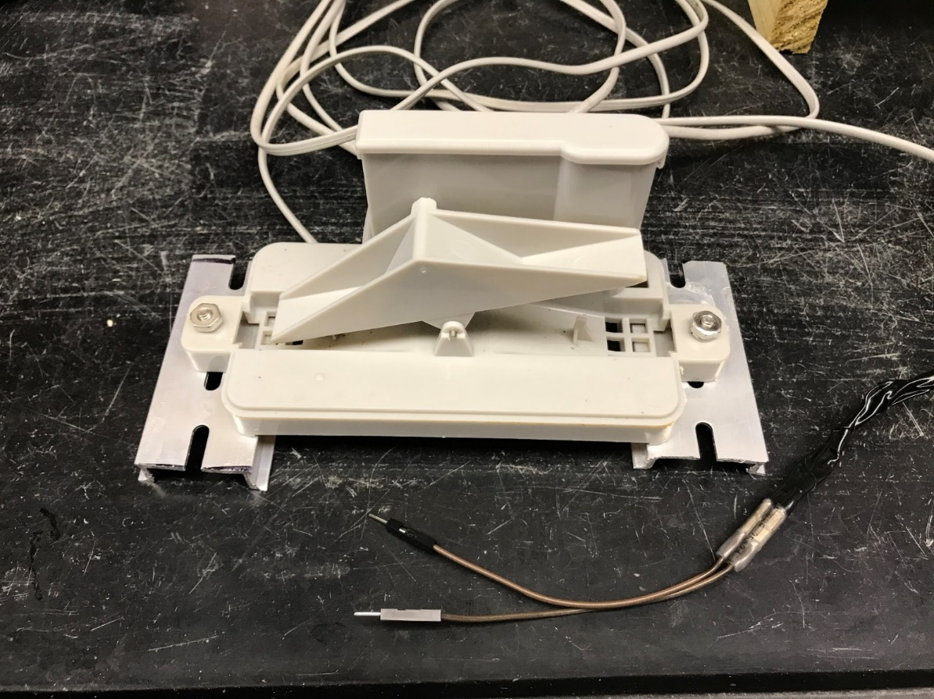

Fig. 1. The tipping bucket rain gauge used to monitor container leachate has two buckets that pivot on an axle. When a bucket fills and tips, a magnet on the bucket mechanism activates a reed switch, allowing a pulse of current to flow to an electrical counter. After one bucket tips and empties, the other bucket begins filling. The bucket had a calibrated tip volume of 1.7 mL which is multiplied by the number of tips to provide a leachate volume.

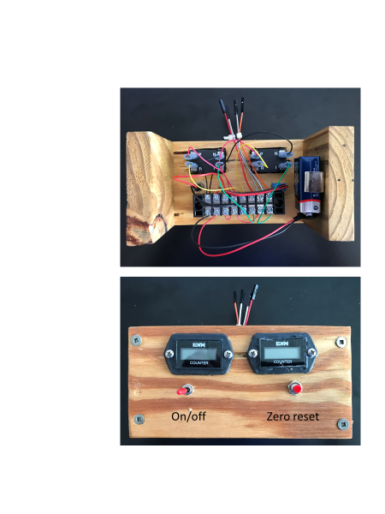

Fig. 2. LCD electronic counter used to monitor a pair of tipping bucket rain gauge sensors for measuring irrigation and container leachate volumes. The handmade counter device is 9 x 18 cm.

Fig. 3. Basic circuit wiring to connect a single tipping bucket rain gauge to an LCD counter. TS=on/off power toggle switch; PBS=normally open push button reset switch. LCD counter connections: P=positive; N=negative; R=reset; I=interrupt.

Fig. 4. Double pan collector method for slowing down and directing leachate into a tipping bucket rain gauge (A). The bottom 43 cm aluminum pizza pan is elevated 10 cm on pieces of lumber and angled downward, so the drain hole is above the gauge (B). A 170 mL bed of pool filter sand placed around the 1.3 cm drain hole slows down the leachate flow rate, helps to keep out debris, and limits evaporation. The top pan (C) is angled in the opposite direction of bottom pan with pieces of plywood so that leachate once drained out of the top pan, meanders through the sand filter of the bottom pan before draining into gauge.

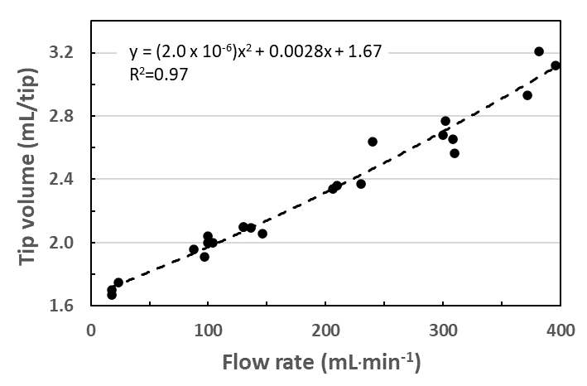

Fig. 5. Effect of flow rate into the tipping bucket rain gauge sensor on the tip volume.

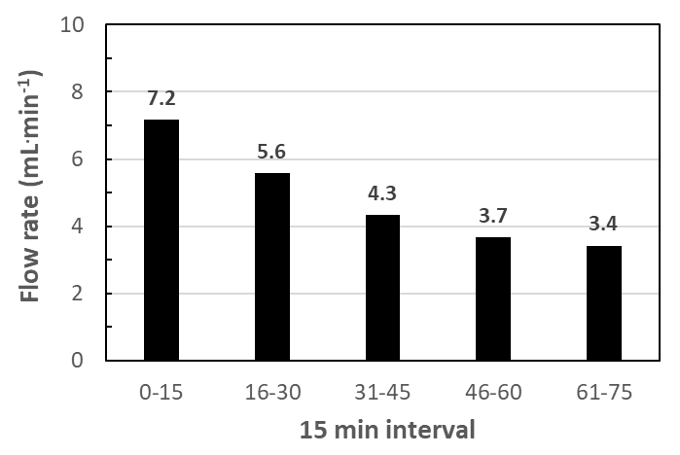

Fig. 6. Flow rate of water out of an irrigation collector with a sand filter. Inflow irrigation water was applied at 320 mL·min-1 for 3 min. Output flow rate was measured with data-logging scales that recorded weights at 30 sec intervals, which were then averaged over five 15 min intervals.